**Lab: Install WordPress and WooCommerce**

WordPress is the most widely used, and fastest growing content management system in nowadays. Most hosting companies make it even easier to install WordPress by including a “1-click install” option, but this usually isn’t the best choice over install WordPress manually. We will soon add another post about why you should avoid “1-click install” forever.

## Install WordPress Manually

So, in this tutorial, we will learn the most secure and professional way to install WordPress manually using cPanel.

## What is cPanel?

cPanel is an online Linux-based web hosting control panel that provides a graphical interface and automation tools designed to simplify the process of hosting a website.

#### Let’s take a look at how easily we can install WordPress manually using cPanel.

## Before installing WordPress

Let us assumes that you have already purchased a hosting plan from any hosting company that uses cPanel. We strongly recommend, and often use, [Bluehost](http://www.bluehost.com/track/pioneerbuy) (paid and come with SSH) or [x10hosting](https://x10hosting.com/) (free).

## Step 1: Login to your cPanel

After buying the hosting plan the company will give your cPanel login URL, Username, and Password. Open the URL in your browser and log in, You will see like this (The figures are from an older version of Cpanel, however they look different, but you should figure it out to use in on any Cpanel with same functionalities)

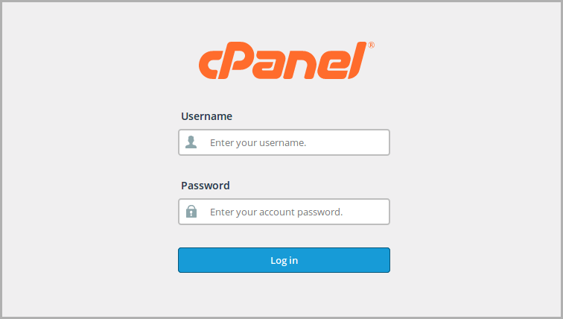

## Step 2: Creating A Database

First of all, we will set up our database and database user with all the Privileges.  
So, Navigate to “Database” section of your cPanel, and click on “MySQL® Databases”.

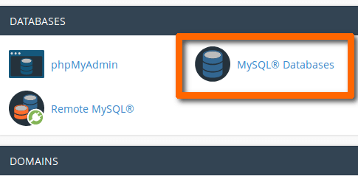

On the next page, you will see a text box asking for the database name. So, enter a name for your database and click Create Database. Most of the time, you will want to name your database with your website name, but it is good to use a confidential name for security purpose. Use lowercase letters to name it.

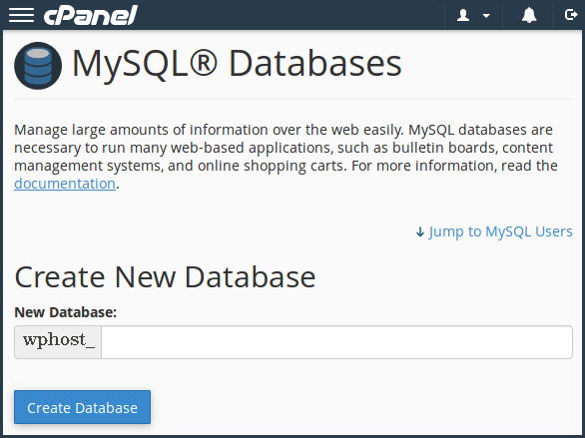

You can see the prefix before the actual database name, this is because we are using shared hosting to make this tutorial. You will need to know your database name for later use. It is better to note down it. After clicking this “Create Database” button you will redirect to database creation confirmation page, just click “Go Back” button to return to the main database page.

## Step 3: Creating A MySQL user

To create a MySQL user scroll down to the “**MySQL Users**” section. Here you will see the same prefix too.  
Enter a username and password for your database user. It is better to use the password generator to create a strong password and finally click Create User.

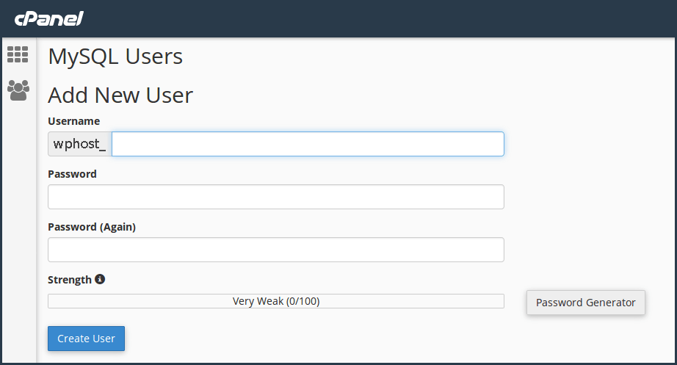

After the user is created, you will again be taken to a confirmation page. Click the “Go Back” button to return to the main databases page.

## Step 4: Adding A User to MySQL Database

Time to add newly added a user to the database to use it. So, you have to give the user permissions to the user to use the database. Under the Add User to Database section, choose your user and your database from the dropdowns available there and click Add.

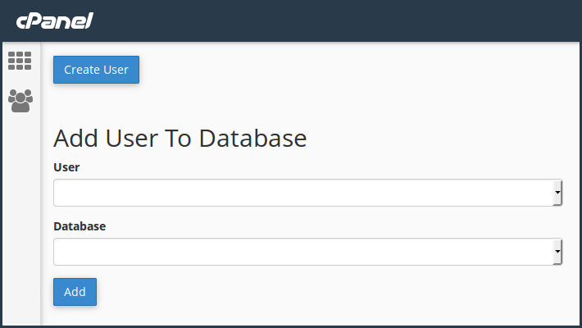

On the next screen, check the All Privileges checkbox to select everything and click Make Changes. Double check before making changes.

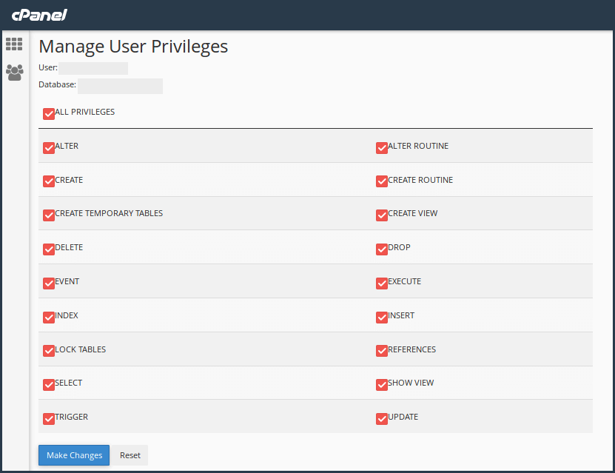

Hey, you just created your database is now ready to install WordPress manually.

## Step 5: Downloading WordPress

**To install WordPress manually we need to download the most recent version of WordPress to a location of your choice at**[**WordPress.org**](https://wordpress.org/download/)

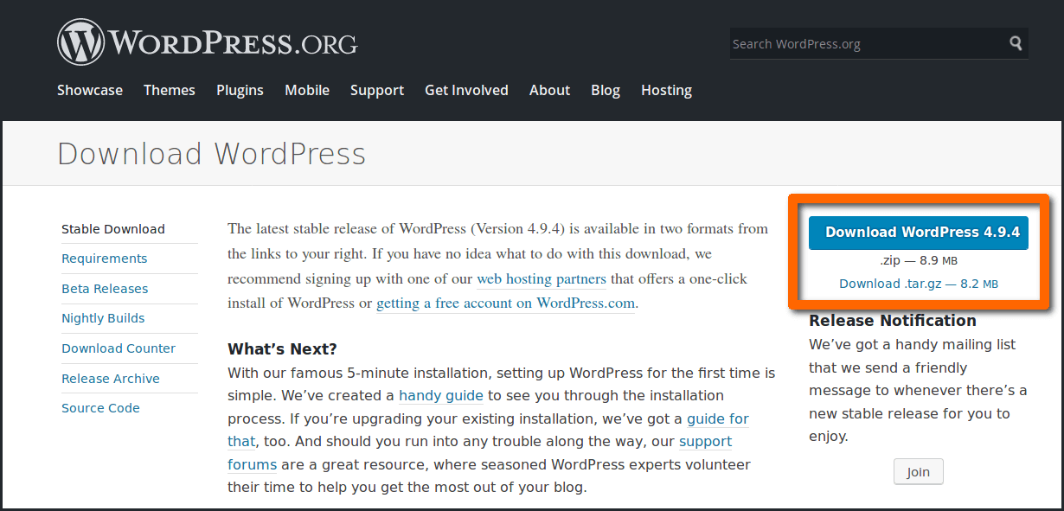

## Step 6: File Manager Setup

To set up the wordpress.zip file, open the cPanel and click on “**File Manager**”

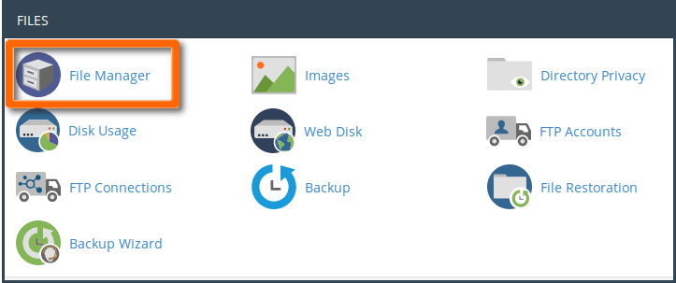

Inside your file manager, you will find a file named “public\_html”. Open it for further setup. Now click on the “Upload” button given at the top of the screen.

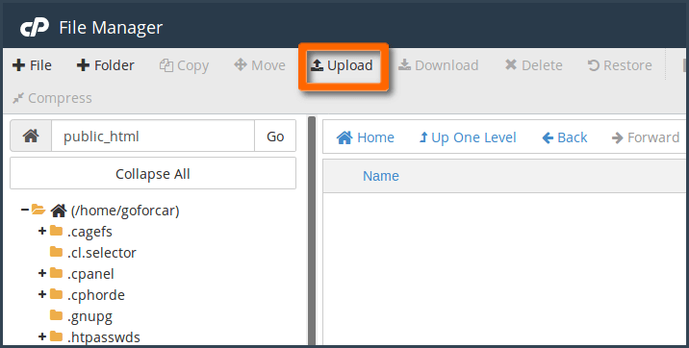

On the next screen you have the cPanel “File Upload” interface, use it to upload the downloaded wordpress.zip file.

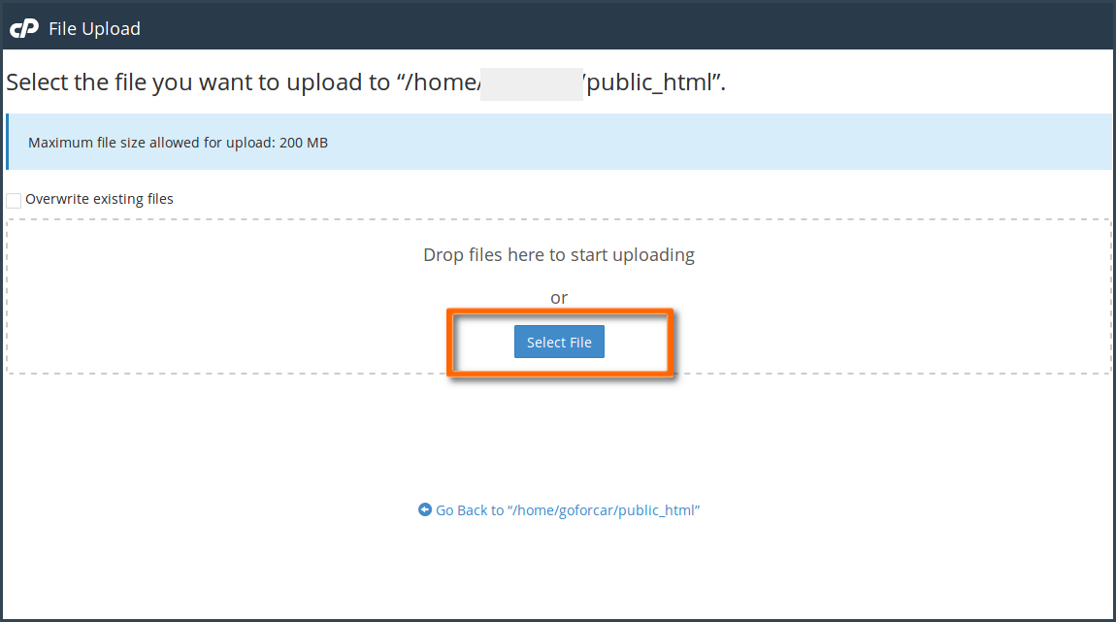

While it completed uploading the file you will see the progress bar automatically changed into green color then just click on “Go Back……”.

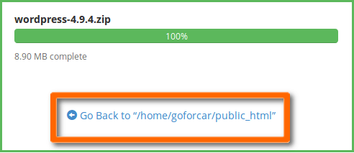

In your public\_html folder, you can see the uploaded file, right click on it and select extract.

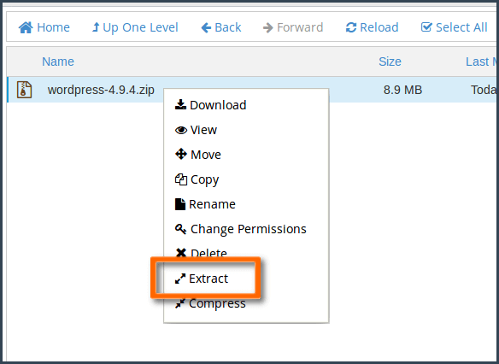

After clicking on extract a pop-up called “Extract” will come up then click on the “Extract Files” button.

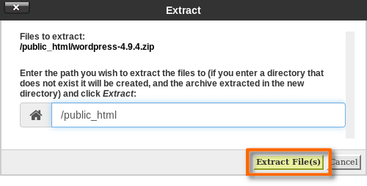

Your zip file will extract like this. Don’t do anything until it completed extracting.

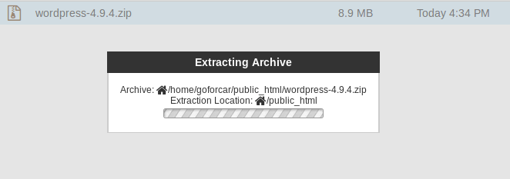Extracting Archive PopUp

Results of extraction process will show like this. Just close it.

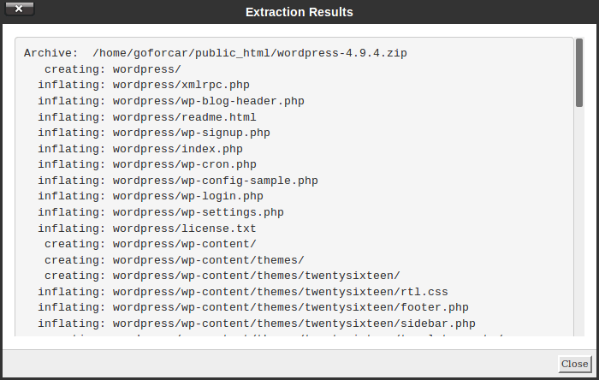

After extraction, you can see a “WordPress” folder inside your public\_html folder. Open it and click on “Select All” button and then click “Move” button as you can see in the image below.

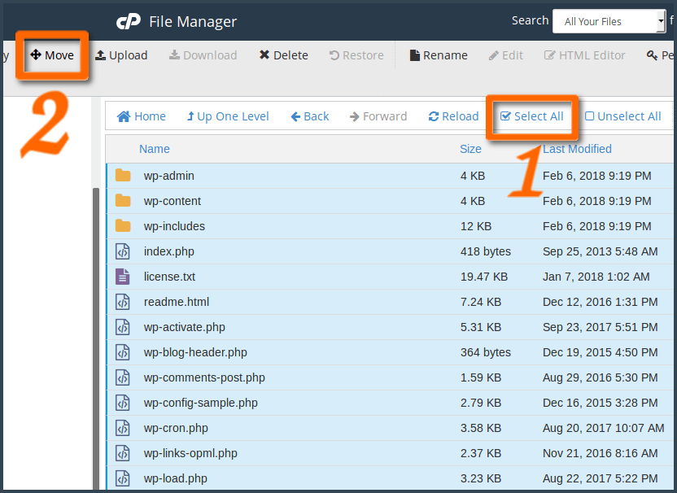

You will be able to see a pop-up called “Move” on your screen like this. Then you need to delete the “WordPress”  from the given path and make it like **/public\_html/** and click on “Move”.

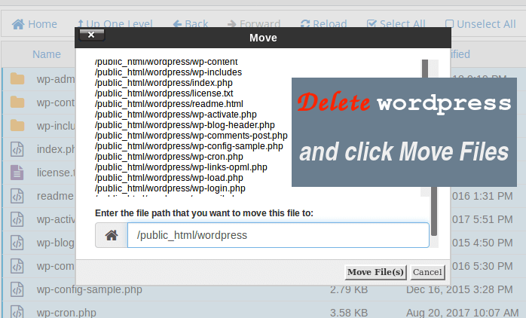

## Step 7 : Setting up wp-config.php file

Tme to find the wp-config-sample.php file in your File Manager and rename the wp-config-sample.php to wp-config.php. To do this right click on it and select “Rename”.

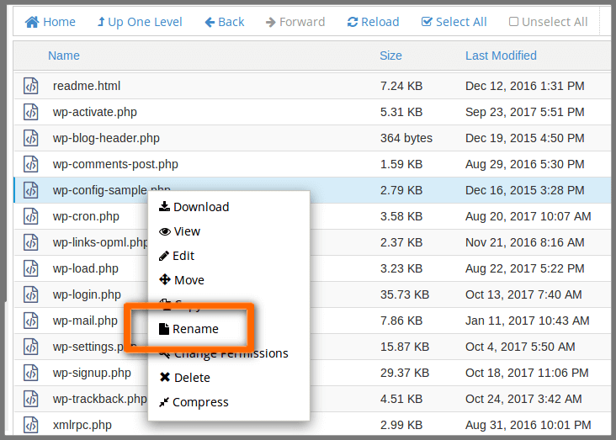

Now Open the wp-config.php file in the Code Editor, it is time to start adding your database information to it. To do this right click on it and select “Edit”.

Locate the line that reads “*define*(*‘DB\_NAME‘*, *‘database\_name\_here‘*);” and add your database name.

Locate the line that reads “*define*(*‘DB\_USER‘*, *‘username\_here‘*);” and add your database username.

Locate the line that reads “define(‘DB\_PASSWORD‘, ‘password\_here‘);” and add your database password.

Within the wp-config.php Then scroll down to find the section that reads “\*Authentication Unique Keys and Salts”.

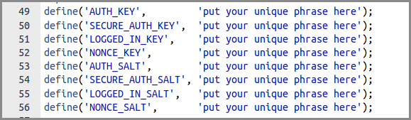

Now visit the WordPress Unique Phrase and Salt Key generator Click here > >. Copy the Unique Phrase and Salt Keys generated by the WordPress API and replace the default ones located in the wp-config.php file. See the image below. Once you are finished with that, hit “Save” and exit the Code Editor and return to the directory root.

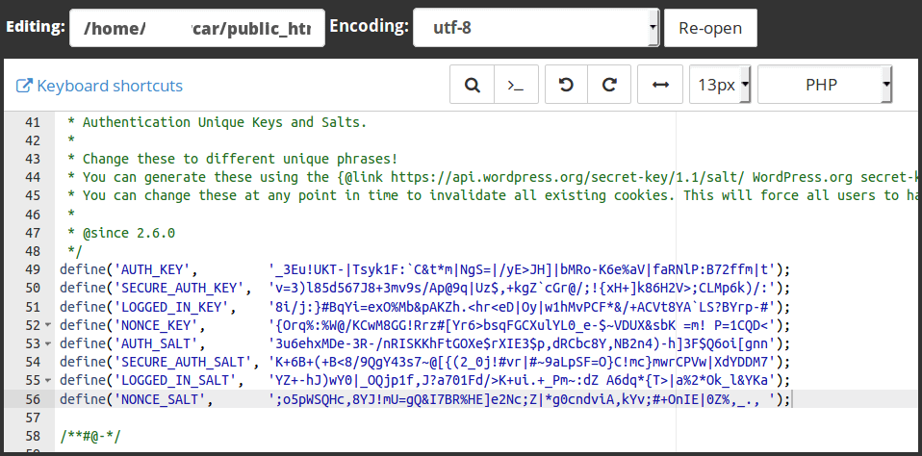

## Step 8: **Run the WordPress Installation Script**

Congratulations, you have just completed your first WordPress installation.

Now it is time to run the WordPress Installation Script by visiting this link [**Example.com/wp-admin/install.php**](http://example.com/wp-admin/install.php) {Change the Example by your own domain name}

Once you have arrived at the next screen, select the language of choice for your WordPress install and click “continue”.

You will then be brought to a page prompting you to enter all of your website’s information such as the site title, your username, your password, and email address.

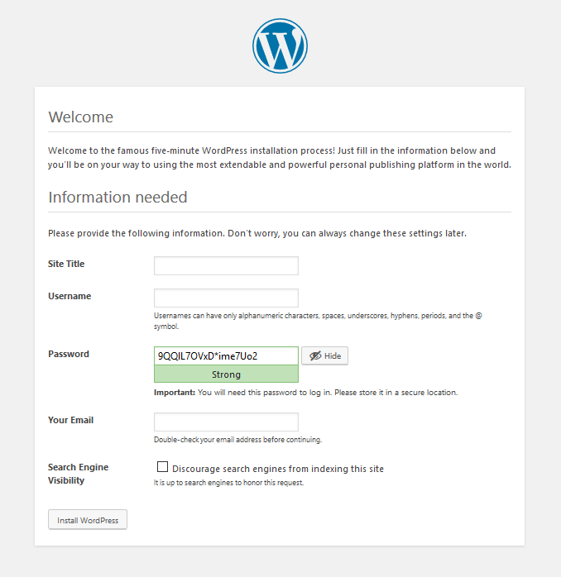

It contains the following fields:

* **Site Title:** Enter the name of the site which you are going to create in WordPress.
* **Username:** Enter the username as per your choice while logging in the WordPress.
* **Password:** Enter password two times to protect your site.
* **Your E-mail:** Enter your e-mail address which helps to recover the password or any update.
* **Privacy:** It allows the search engine to index this site after checking the check-box.

If you are developing a new site at this address, so it may also be a good idea to tick the box “Discourage search engines from indexing this site”. So that Google, Bing, etc. don’t index your site before it is populated with content and ready to launch. Otherwise, it may leave bad impressions to the search engines. Because you don’t have any content yet. You will later able to change it from your Dashboard.

Once you have filled in all of the information, hit “Install WordPress” and you are all finished!

You will be asked to log in to your new site. Enter your username and password and this will let you to your brand new WordPress dashboard.

## Step 9: **Install WooCommerece Plugin**

Before we start with the process of installing WooCommerce plugin, make sure you have downloaded the plugin itself whether from WordPress.org or from http://www.woothemes.com/woocommerce/

Now when you have it downloaded on your computer you may start installation process. There are two ways for doing that: from WordPress admin panel and via FTP.

Let's see how it goes the easy way - from WordPress admin panel.

## Step 9 – Option 1. Install WooCommerce using WordPress admin panel

On your side menu, place your cursor on Plugins and then click on Add New.

[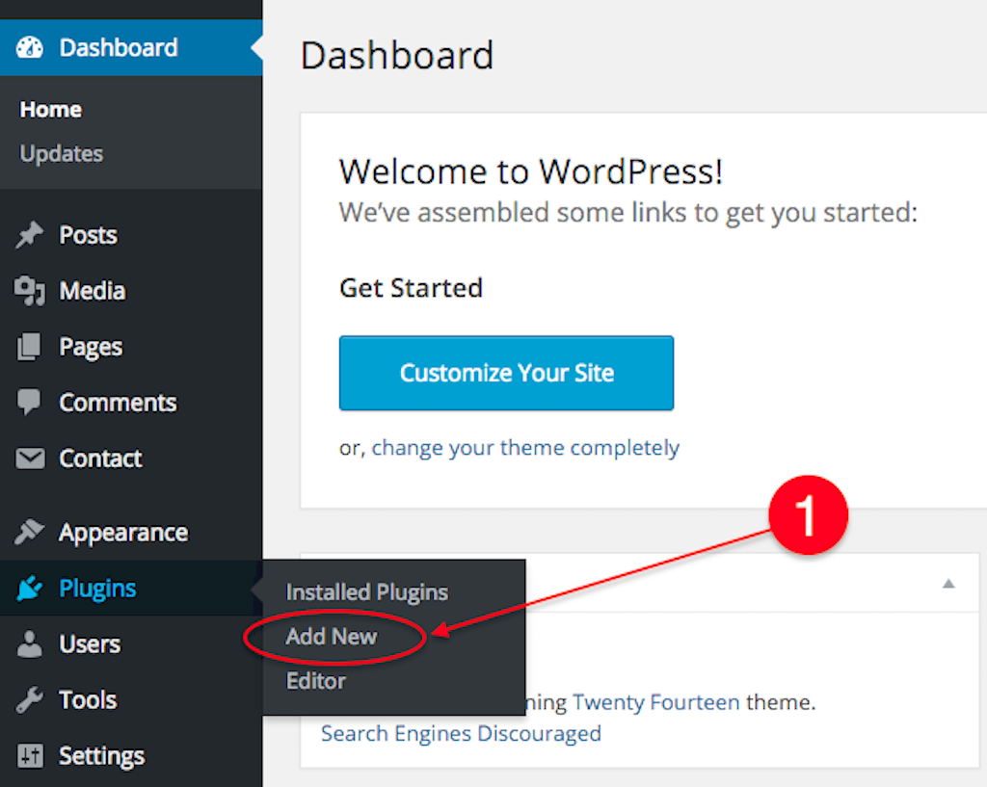](https://tickera-wpsalad.netdna-ssl.com/wp-content/uploads/2015/11/1.png?x46941)

On the Add Plugins page select Upload Plugin

[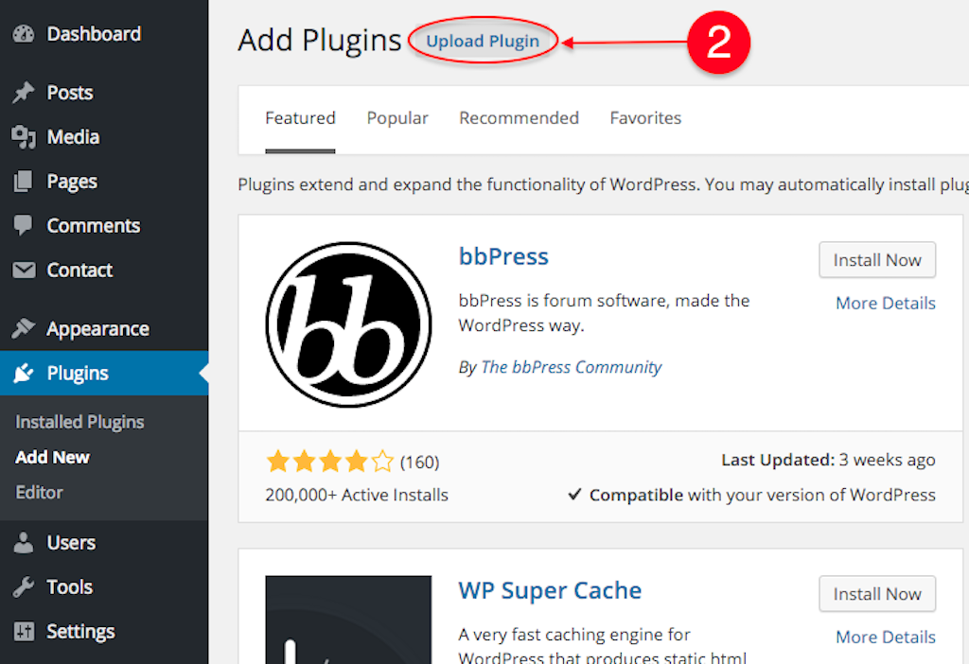](https://tickera-wpsalad.netdna-ssl.com/wp-content/uploads/2015/11/2.png?x46941)

Now select Choose File and browse to woocommerce.zip file on your computer, then click Open.

[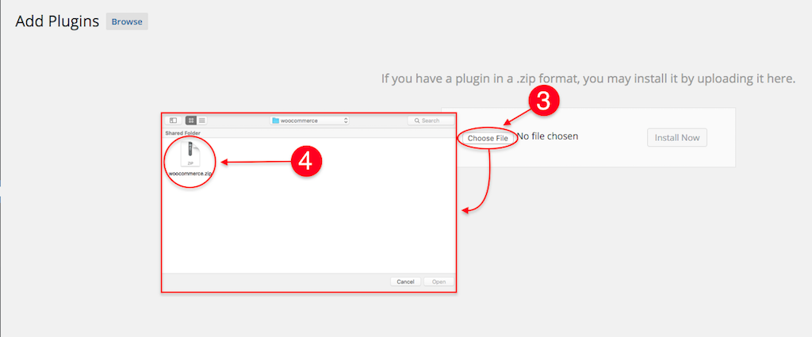](https://tickera-wpsalad.netdna-ssl.com/wp-content/uploads/2015/11/3.png?x46941)

When done, hit Install Now button and the installation procedure will start. Wait until it is done and then click Activate Plugin, as in the picture below.

[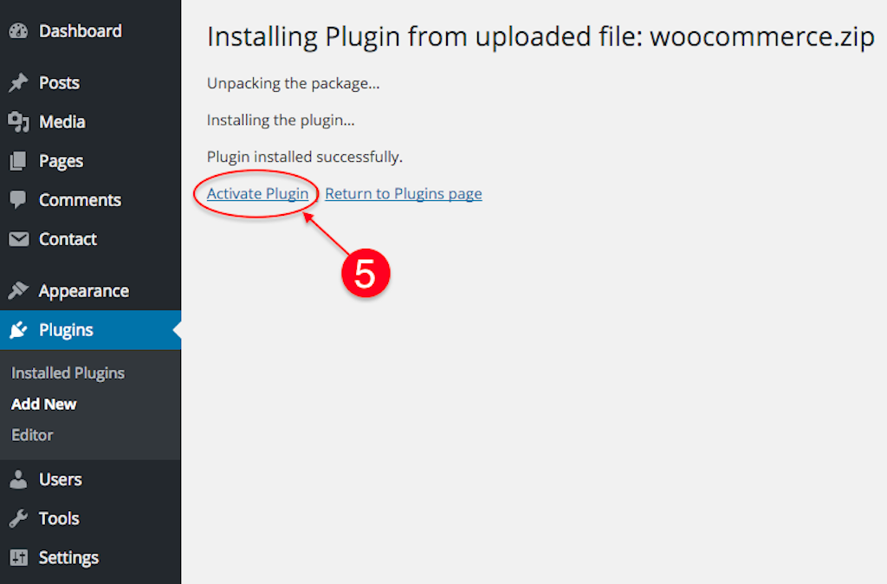](https://tickera-wpsalad.netdna-ssl.com/wp-content/uploads/2015/11/5.png?x46941)

## Step 9 - Option 2. Install WooCommerce using FTP manager

This method is not very user friendly (although it is not at all complicated as it may seem at the beginning) but it offers complete overview of the stuff happening "behind the scene".

For this method, you will need an FTP manager such as [Filezilla](http://filezilla-project.org/download.php?type=client" \o "FileZilla" \t "_blank) -All Platform, [FireFTP](http://fireftp.mozdev.org/" \o "FireFTP" \t "_blank) -All Platform, [Cyberduck](http://cyberduck.ch/" \o "Cyberduck" \t "_blank) -Mac Only, [WinSCP](http://winscp.net/eng/index.php) -Windows Only, or any other for that matter.

With this installation method you will notice the difference in the very beginning as you will need to unpack downloaded woocommerce.zip on your hard drive. When finished unpacking, you will end up with a folder named "woocommerce".

Now, head to your FTP client of choice and connect to your FTP account. Usually, FTP managers have two "sides" where the one is your local drive and the other is your server. Browse to your WordPress installation folder on the server and head to wp-content/plugins folder. Next, browse to the woocommerce folder on your hard drive, select the whole folder and drag&drop it to wp-content/plugins folder on your server.

[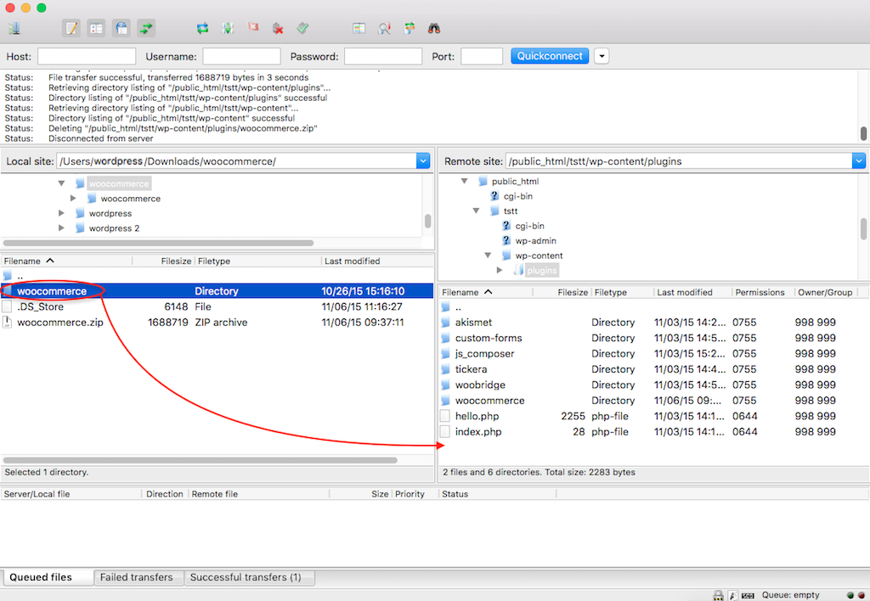](https://tickera-wpsalad.netdna-ssl.com/wp-content/uploads/2015/11/11.png?x46941)

Wait until upload process finishes. Then log in to your WordPress admin panel and head to Plugins. Your WooCommerce plugin should be now listed with all of the other plugins (if not, you probably have uploaded it to the wrong folder). Now, go ahead and click Activate.

[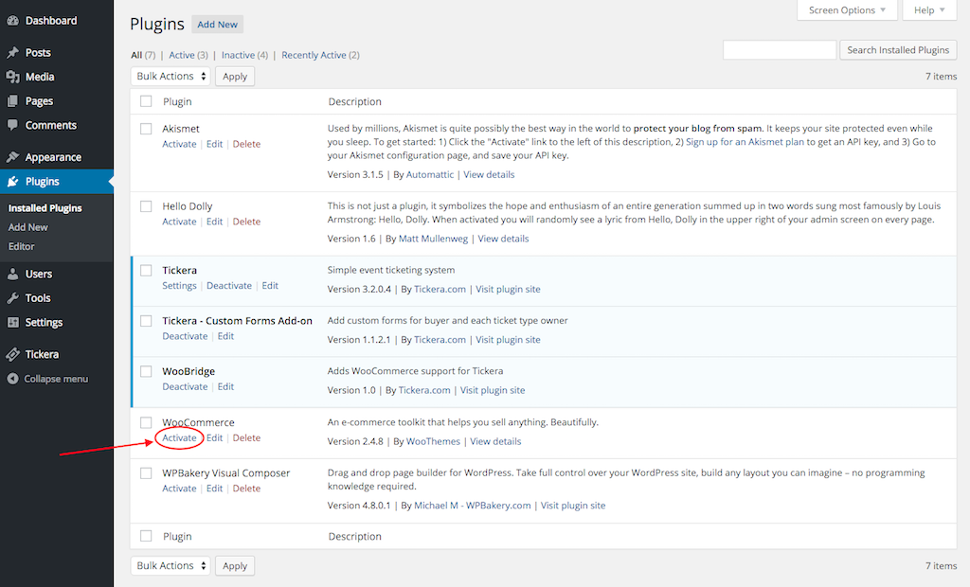](https://tickera-wpsalad.netdna-ssl.com/wp-content/uploads/2015/11/21.png?x46941)

## Step 10 - Quick setup

Regardless of what method you decide to use, it comes down to the same result - successfully installed plugin. Now, when the plugin is installed, you will need to activate it and that's when the magic pops in. The good people who made the WooCommerce plugin made pretty little quick setup guide which will guide you through the basic setup options. The options through this guide are well explained and easy to understand. However, if you set something wrong, it's really not a big deal as all of those settings can later be edited through standard WooCommerce Settings.

[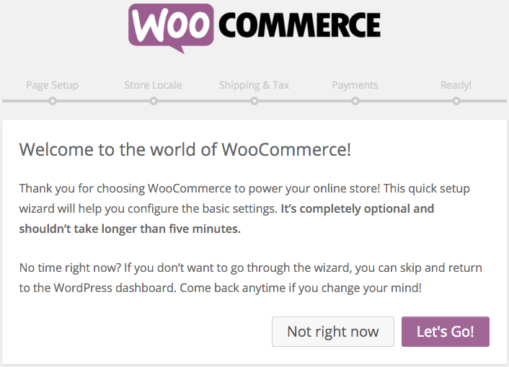](https://tickera-wpsalad.netdna-ssl.com/wp-content/uploads/2015/11/12.png?x46941)

This is the welcome screen in which you may opt to run through quick setup or just quit and set up later through standard WooCommerce settings. We'll choose Let's Go and it will lead us to the next page of the quick setup.

[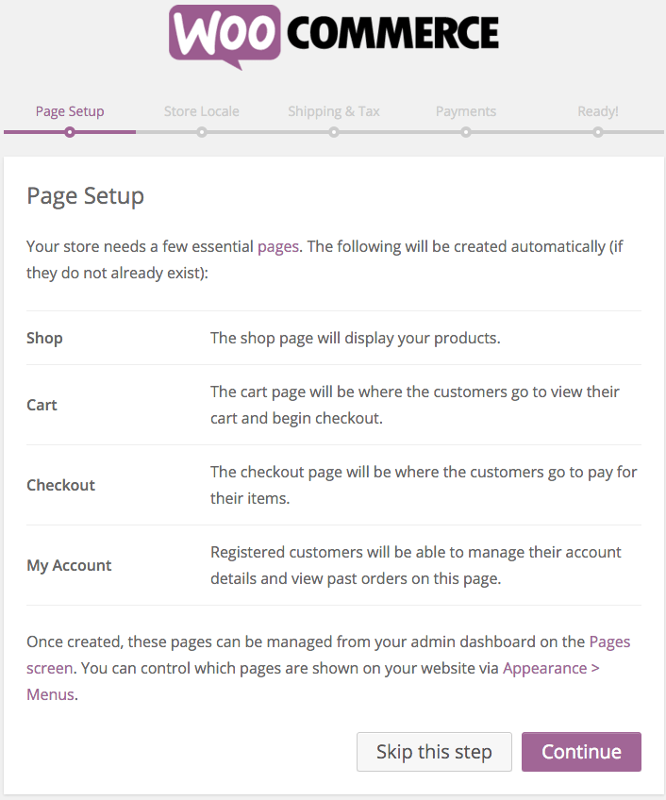](https://tickera-wpsalad.netdna-ssl.com/wp-content/uploads/2015/11/22.png?x46941)

This page informs us that it will create the pages that are necessary for WooCommerce to work properly. Just click Continue and let it do whatever it needs to do.

[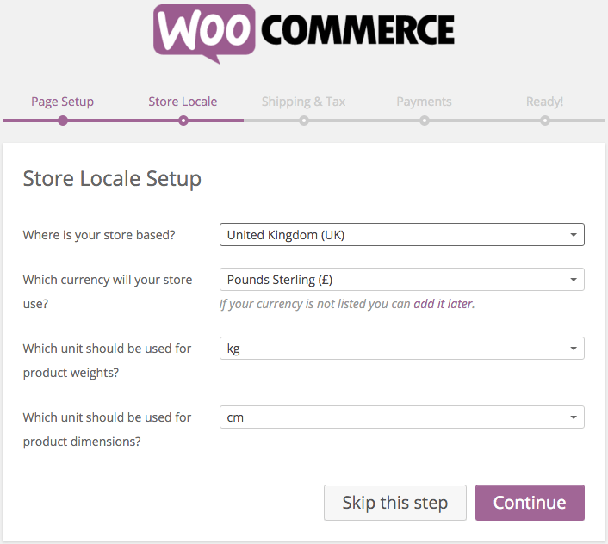](https://tickera-wpsalad.netdna-ssl.com/wp-content/uploads/2015/11/31.png?x46941)

When WooCommerce pages are created, it will ask to setup your Store Locale. Here you can set up the location of your store, currency you would like to use and product weight and dimensions units. Again, you can set it up here or you may skip it and set it up later in WooCommerce settings. If you choose to set it up now, just click Continue when done.

[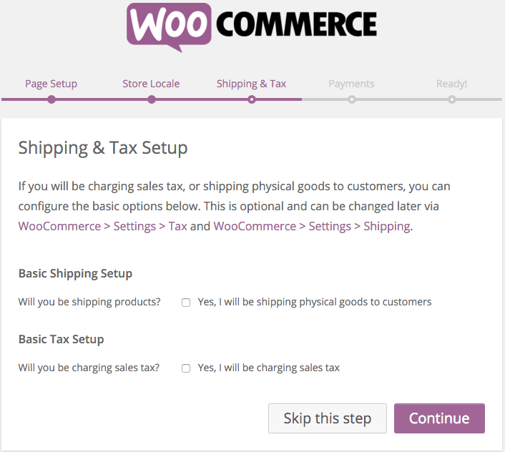](https://tickera-wpsalad.netdna-ssl.com/wp-content/uploads/2015/11/4.png?x46941)

This page allows you to set Shipping and Tax. If you are going to use WooCommerce just for selling tickets and nothing else, you may leave the Basic Shipping Setup checkbox unchecked and if you plan to charge tax on ticket sales, you may check the Basic Tax Setup checkbox. All of it is optional and can later be changed in WooCommerce settings.

[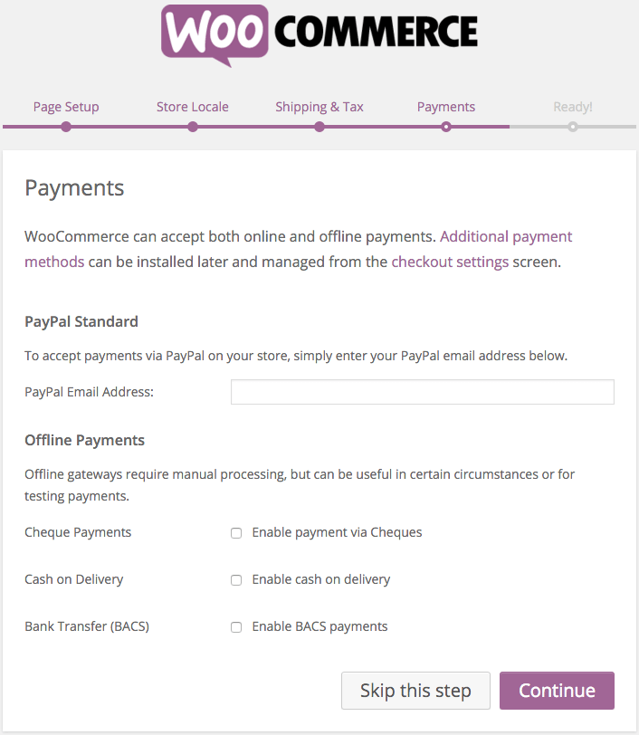](https://tickera-wpsalad.netdna-ssl.com/wp-content/uploads/2015/11/51.png?x46941)

If you plan to use PayPal Standard, you can enter your PayPal email address here where you want to accept payments. Also, if you want to allow Cheque Payments, Cash on Delivery and Bank Transfer, you may check the corresponding checkboxes. However, if you don't plan to use any of the methods offered here, just leave it all as it is and later choose the one you want from vast selection of  payment methods in WooCommerce add-ons.

[](https://tickera-wpsalad.netdna-ssl.com/wp-content/uploads/2015/11/6.png?x46941)

This is the final stage that informs you that your store is now ready to be used and offers to create your first product right away. It also contains valuable links to WooCommerce setup and knowledge base. Right on the bottom is the link to return to the WordPress Dashboard.

## Step 11 – Add some sample products

Add some products to your new ecommerce website. You can [use any free theme you like](https://themegrill.com/blog/free-woocommerce-themes/). You do not need to add many products or buy any extensions. Just try to understand how you can convert your WordPress using WooCommerce plugin and a theme to an online shop. At the end, share your online store front page. You can add this to your GitHub page as one of the labs you have done in this course.